|  |  |
| --- | --- |
| Full name: _______________________________ | Date: ___/ ___/ ______ |
| Class: ________ | Review: Grade 2 |

**EXERCISE 1 – GRADE 2**

1. **Look and read. Put a tick (✓) or a cross (🞪) in the box.**

There are two examples.

|  |  |  |
| --- | --- | --- |
| *Examples* |  |  |
|  | This is an apartment. | 🗵 |
|  | A baby’s in the bathroom. | ☑ |
| *Questions* |  |  |
| 1 | They’re in the bedroom. | □ |
| 2 | She’s in the bathroom. | □ |
| 3 | A family’s in living room. | □ |
| 4 | Grandma’s in the kitchen. | □ |

1. **Look at the pictures. Look at the letters. Write the words.**

|  |  |  |  |
| --- | --- | --- | --- |
| *Example* |  |  |  |
|  |  | l i v i n g r o o m | o m v g i i n o l r |
| *Questions* |  |  |  |
| 1 |  | _ _ _ _ _ _ _ | k c h e i t n |
| 2 |  | _ _ _ _ _ _ _ | b o m r o e d |
| 3 |  | _ _ _ _ _ | u o h s e |
| 4 |  | _ _ _ _ _ _ _ _ _ | a t a m t e n r p |
| 5 |  | _ _ _ _ _ _ _ _ | m t r o o b h a |

1. **Look at the pictures and read the questions. Write one-word answers.**

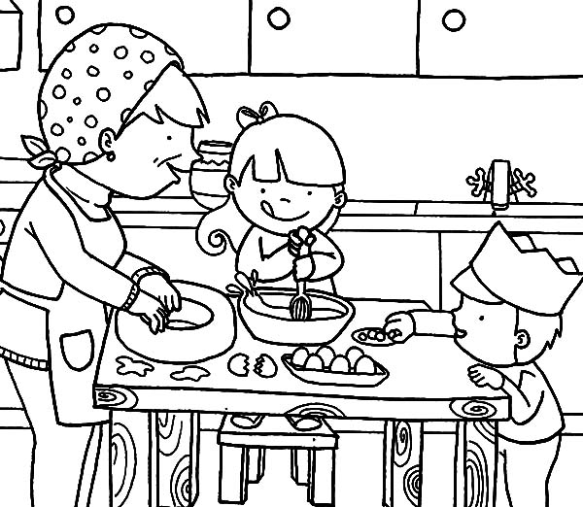

*Examples*

|  |  |
| --- | --- |
| Where are the children and her grandma? | in the kitchen |
| What are they doing? | baking |

*Questions*

|  |  |
| --- | --- |
| 1 Where are the eggs? | on the ………………….. |
| 2 How many people in the kitchen? | ………………….. |

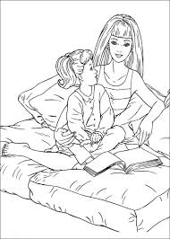

|  |  |
| --- | --- |
| 3 Where are the girl and her mom? | in the …………………….. |
| 4 What are they doing? | …………………….. |

🙞🙞 The end 🙜🙜

**ĐÁP ÁN**

**EXERCISE 1- GRADE 2**

I/ Nhìn và đọc. Đặt dấu (✓)và dấu (🞪) vào ô trống.

1. They’re in the bedroom. 🗵
2. She’s in the bathroom. 🗵
3. A family’s in living room. ☑
4. Grandma’s in the kitchen. ☑

II/ Nhìn vào những bức tranh. Nhìn vào những chữ cái. Viết từ.

1. kitchen
2. bedroom
3. house
4. apartment
5. bathroom

III/ Nhìn vào những bức tranh và đọc câu hỏi. Viết 1 từ trả lời.

1. table
2. three
3. bedroom
4. reading/ talking